Object oriented programming
LAB FILE

NAME – VANSH MADAAN
BATCH- B4
SAP_ID- 500123857
ROLL_NO - R2142230412
Experiment-4
1. Create a Student class with attributes for name and age. Implement a default constructor to assign default values and a parameterized constructor to initialize the attributes with user-defined values.
Create objects using both constructors and display their details.
=>
//ERROR - CODE
public class Student {
String name; int age; public Student() { name = "Ananya"; age = 20;
}
public Student(String name, int age) { this.name = name; this.age = age;
}
public static void main(String[] args) {
Student s1 = new Student();
Student s2 = new Student("Nishtha", 21);
System.out.println("Default constructor-");
System.out.println("Name: " + s1.name + " Age: " + s1.age);
System.out.println("parameterized constructor-");
System.out.println("Name: " + s2.name + " Age: " + s2.age);
}}
class Student { String name; int age;
Student() {
name = "ANANYA KARN";
age = 20;
}
Student(String name, int age) { this.name = name; this.age = age;
}
void display() {
System.out.println("Name: " + name);
System.out.println("Age: " + age);
}} public class Exp4_first { public static void main(String[] args) {
Student s1 = new Student();
Student s2 = new Student("Rahul Sharma", 22); s1.display(); s2.display();
}}
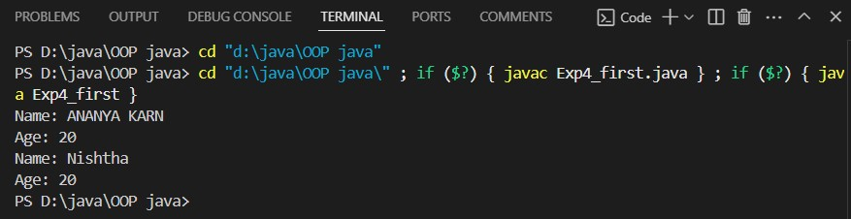
2. Create a BankAccount class with a private variable balance to store the account balance. Implement a public method deposit(double amount) to add funds, a protected method withdraw(double amount) to deduct funds, and a default-access method checkBalance() to display the current balance. Create an object of the class and demonstrate which methods and variables can be accessed both inside and outside the class. public class BankAccount { private double balance; public BankAccount(double initialBalance) { balance = initialBalance;
}
public void deposit(double amount) { if (amount > 0) { balance += amount;
System.out.println("Deposited: $" + amount);
} else {
System.out.println("Invalid deposit amount!");
}
}
void checkBalance() {
System.out.println("Current balance: $" + balance);
}
public static void main(String[] args) {
BankAccount account = new BankAccount(1000); account.deposit(500); account.checkBalance();
account.withdraw(200); account.checkBalance();
}
protected void withdraw(double amount) { if (amount > 0 && amount <= balance) { balance -= amount;
System.out.println("Withdrawn: $" + amount);
} else {
System.out.println("Invalid withdrawal amount!");
}
}
}
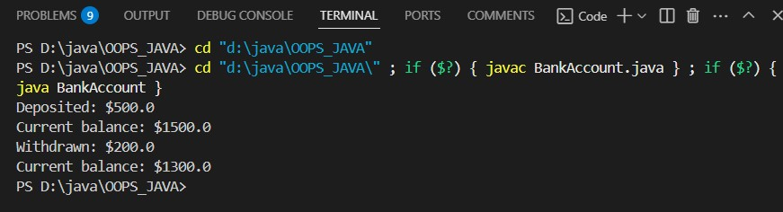
3. Create a University class that has a static variable universityName and a non-static variable studentName. Include a static method to display the university name. Then, create multiple student objects to demonstrate how the static variable is shared among all instances, while the non-static variable holds unique values for each object.
=> class University { private static String universityName = "Global University"; private String studentName;
public University(String studentName) { this.studentName = studentName;
}
public static void displayUniversityName() {
System.out.println("University Name: " + universityName);
}
public void displayStudentInfo() {
System.out.println("Student Name: " + this.studentName);
System.out.println("University: " + universityName);
}
}
public class UniversitySystem { public static void main(String[] args) {
University.displayUniversityName();
University student1 = new University("Alice Johnson");
University student2 = new University("Bob Smith"); University student3 = new University("Charlie Brown"); student1.displayStudentInfo(); student2.displayStudentInfo(); student3.displayStudentInfo();
}
}
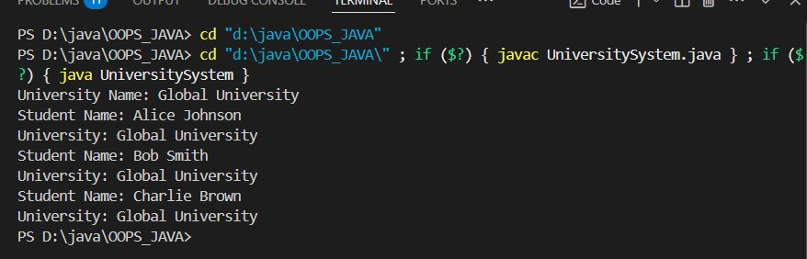
4. A student is developing a course registration system that allows students to enroll in courses. Each course has a course name and a course code. Implement a Course class with appropriate attributes and use the “this” keyword to differentiate between class attributes and constructor parameters during initialization. Create an object of the Course class and display the course details.
=> class Course { String CourseName; int CourseCode; void CourseName(String CourseName) { this.CourseName = CourseName;
System.out.println(CourseName);
}
void CourseCode(int CourseCode) { this.CourseCode = CourseCode;
System.out.println(CourseCode);
}
}
public class lab4_ques_four { public static void main(String[] args) { Course student1 = new Course(); student1.CourseName("Computer Science"); student1.CourseCode(11845);
}
}
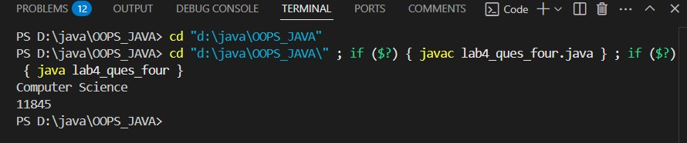
5. A company wants to develop an Employee Management System to track employee details such as name, department, salary, and employee ID. The system should also calculate the total salary expenditure and keep a record of the total number of employees. Implement a Java program by creating an Employee class that includes instance variables for employee ID, name, department, and salary. The class should have a default constructor that initializes employee details with default values and a parameterized constructor that sets employee details based on user input. Use a static variable totalEmployees to track the total number of employees and implement a static method to display this count. Additionally, define a method calculateSalary() that returns the salary of the employee and another method displayEmployeeInfo() to display all employee details. To ensure data encapsulation, mark the salary variable as private and provide a public method to access it. Declare the totalEmployees variable as static so that it is shared among all instances. In the main method, create multiple Employee objects using both default and parameterized constructors. Use the “this” keyword in the constructors to distinguish between class variables and constructor parameters. Finally, display the total number of employees and the salary details for each employee. The program should successfully demonstrate the behavior of static and non-static members, the initialization of objects using constructors, and the role of access modifiers in an employee management scenario.
=> public class Employee { private int employeeId; private String name; private String department; private double salary; static int totalEmployees = 0; public Employee() { this.employeeId = 0; this.name = "Unknown"; this.department = "Unknown";
this.salary = 0.0; totalEmployees++;
}
public Employee(int employeeId, String name, String department,
double salary) { this.employeeId = employeeId; this.name = name;
this.department = department; this.salary = salary; totalEmployees++;
}
public double calculateSalary() { return this.salary;
}
public void displayEmployeeInfo() {
System.out.println("Employee ID: " + this.employeeId);
System.out.println("Name: " + this.name);
System.out.println("Department: " + this.department);
System.out.println("Salary: $" + this.salary);
}
public static void displayTotalEmployees() {
System.out.println("Total number of employees: " +
totalEmployees);
}
public double getSalary() { return this.salary;
}
public static void main(String[] args) {
Employee employee1 = new Employee();
Employee employee2 = new Employee(101, "John Doe", "Engineering", 75000); // Using parameterized constructor
Employee employee3 = new Employee(102, "Jane Smith",
"Marketing", 65000); employee1.displayEmployeeInfo(); employee2.displayEmployeeInfo(); employee3.displayEmployeeInfo();
Employee.displayTotalEmployees();
}
}
